By: Eng. Abdelrahman Matarawy

Student Management System

Mastering Embedded System Online Diploma

Second Term (Final Project 2)

My Profile: [my progress page](https://www.learn-in-depth-store.com/account/blank-4)

[(learn-in-depth-store.com)](https://www.learn-in-depth-store.com/account/blank-4)

* **Problem Statement:**
* Program to Build a Simple Software for Student Information Management System which can Perform the Following Statement.
* Store The First Name of Student.
* Store The Last Name of Student.
* Store Unique Roll Number For every Student.
* Store The GPA of every student.
* Store The Courses Registered by the Student.
* **Approach:**
  + The Main Idea is to Form Individual Functions for every Operation. Then Unified All Functions together to Form Software.
* Add Student Details from File.
* Add Student Details Manually.
* Find Student by the given Roll Number.
* Find Student by the given First Name.
* Find Students Registered in a Course.
* Total Number of Students in List.
* Delete a Student from Queue List.
* Update Student Data.
* Show All Students in Our Queue.
* 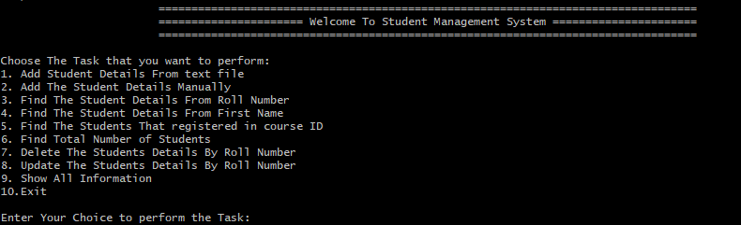Starting The Program:
* Stay Waiting Until User Choose from Options …

* Add Student Details from File:
  + Get Data from File and Add Student to Our List. While Adding the Student to the List, Check for the uniqueness of Roll Number.
    1. The File Reading From it:

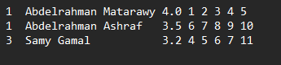

* + 1. After Adding those Students to our Queue List:

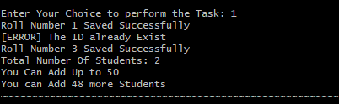

“Second Student not Added because he has the Same ID of first Student.”

* Add Student Details Manually:
  + Get Data from File and Add Student to Our List. While Adding the Student to the List, Check for the uniqueness of Roll Number.
    1. Case 1 Adding Id Which Not Exist in List:

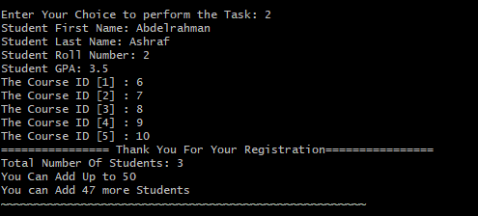

* + 1. Case 2 When Try to Add the Same Course ID Twice:

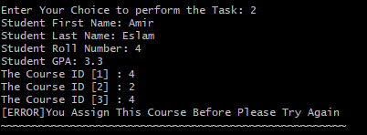

“In Case Adding ID of The Same Course Twice the Registration Process Will Stop”

* Show Students After Adding from File and Manually:

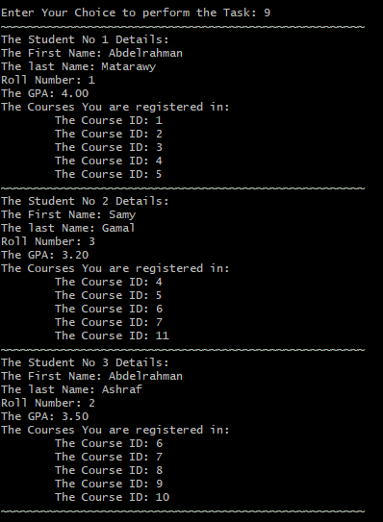

* Search By Roll Number:
  + This Function it to Find the Student Record for the given Roll Number and Print Student Details.
    1. Case 1 Search with ID exist in List:

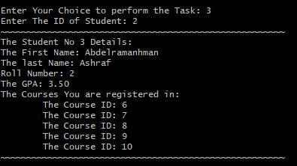

* + 1. Case 2 Search with ID Not Found in List:



* Search By First Name:
  + This Function it to Find the Student Record for the given Roll Number and Print Student Details.
    1. Case 1 Search with Name Exist in List:

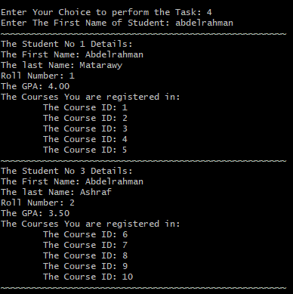

* + 1. Case 2 Search with Name not Exist:



* Students Registered in Course:
  + This Function to find All Students Who Registered for a given Course ID.
    1. Case 1 Course ID Exist:

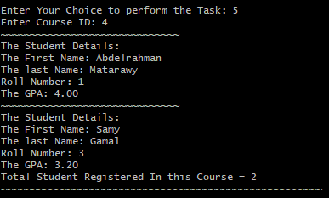

* + 1. Case 2 Course Not Exist:



* Total Students:
  + This Function to Print total Number of Students.
* Delete A Student:
  + This Function to Delete Student with his Roll Number.
    1. 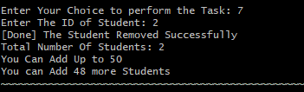Case 1 as Exist ID:
    2. Case 2 as ID is not Exist:



* Show Students After Deleting:

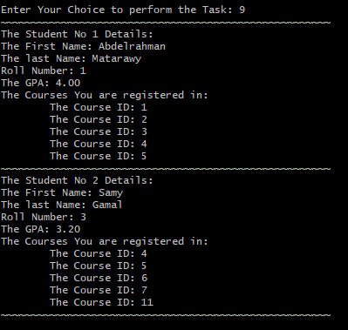

* Editing Student Data:
  + This Function is to Update the Student records. This Function does not ask for new details for all Fields but the User Should be able to Pick and Choose what he wants to Update.

1. 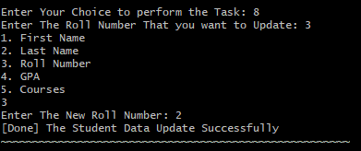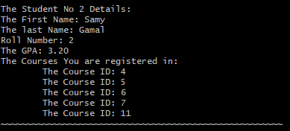By Edit Roll Number:
2. 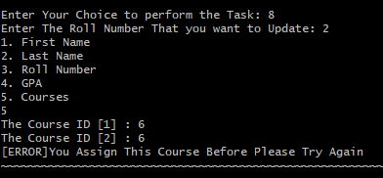By Edit Courses:

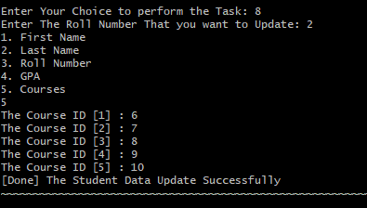

* End of Program: